Homework 1 Solutions

Answer the following questions as clearly as possible. Bullet points are fine. (TOTAL 100 Points)

* **Conceptual Questions:**

**Q1. Basic Concepts of Trade (5 Points)**

1. Provide the reasons for the resurgence of trade that led to the second golden age.

**Solution:**

With the end of World War II in 1945, and the **reductions in tariffs** following the formation of the General Agreement on Tariffs and Trade, countries such as the United Kingdom, Europe, and Australia regained their trade. In general, world trade improved after 1950 for some countries and by 1960 for others. Adding to the trade growth was the **reduction in transportation costs** that occurred with the **invention of the shipping container** in 1956.

**Q2. Ricardian Model (15 Points)**

1. Give four reasons for why countries trade goods with each other.

**Solution:**

Trade determinants include differences in proximity (geographic distance between countries), differences in natural resources (land, labor, and capital), differences in costs of offshoring, and differences in level of technology.

1. What are the assumptions of the Ricardian Model?

**Solution:**

1. L is the only factor of production
2. All L is homogeneous (that is, there is no skill bias) and all occupations pay the same wage
3. No diminishing returns to labor
4. L is perfectly mobile between sectors
5. There is full employment in the economy
6. Market is perfectly competitive
7. According to Ricardo’s theory of comparative advantage theory, briefly discuss how relative technological difference determines pattern of trade.

**Solution:**

**Relative technological difference** implies difference in opportunity cost of producing the good. In the Ricardian world, the country which has **lower opportunity cost** in producing the good has comparative advantage in that good, this implies that the country **specializes** in production of that good and **exports** that good to the other country.

**Q3. Specific Factor Model (10 Points)**

1. How does the Specific Factor Model differ from the Ricardian Model?

**Solution:**

The Ricardian Model assumes Labor is the only factor of production and MPL is constant which makes the PPF a straight line. However, in the Specific model there are more than one factors of production (Labor, Capital and Land), and MPL is diminishing which makes PPF to be concave. In the Ricardo Model, everyone gains from trade, but in the Specific Factor Model, trade will generate gains for some factor owners and losses for others. However, the overall gains from those who benefit from trade generally exceed the losses of those who are harmed.

(Note: When you write differences of two (or more) models, you must specify the characteristics of all models. For example, here we specify the characteristics of both the Ricardo and Specific Factor models)

1. Home is considering whether to engage in the international trade of apples and oranges. Suppose that the world price of apple is lower than Home’s no-trade price but its no-trade orange price is lower than the world price. Assume that land is specific to the production of apple and that labor is free to move across sectors. Do you think the landowners will support the move to free trade? Explain.

**Solution:**

Landowners will not support the move because the world price of apple is lower than Home’s no-trade price. By engaging in trade, the landowners would be worse off because the rental on land will fall due to the decrease in the price of apple.

(Note that land is specific to apple sector, that means land is used only in apple sector, and not in orange sector.)

* **Numerical Questions: (40 Points)**

**Q4.**

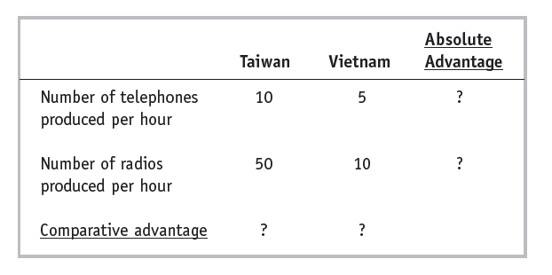

1. Which country has absolute advantage in the production of telephones? radios?

**Solution:**

Taiwan has higher MPL for both telephones and radios compared to Vietnam. This implies Taiwan can produce more of both goods per hour than Vietnam. Hence, Taiwan has an absolute advantage in the production of both telephones and radios.

1. Which country has a comparative advantage in the production of telephones? radios?

**Solution:**

Opportunity Costs

Taiwan Vietnam

Telephones 5  **2**

Radios **1/5**  1/2

* Vietnam has a lower opportunity cost of producing telephones relative to Taiwan. Hence, Vietnam has a comparative advantage in the production of telephones.
* Taiwan has a lower opportunity cost of producing radios relative to Vietnam. Hence, Taiwan has a comparative advantage in the production of radios.

1. Assume that the total labor supply in Taiwan is 4 and the total labor supply in Vietnam is 8. Draw the PPF for each country. Please label the maximum output levels.

**Solution:**

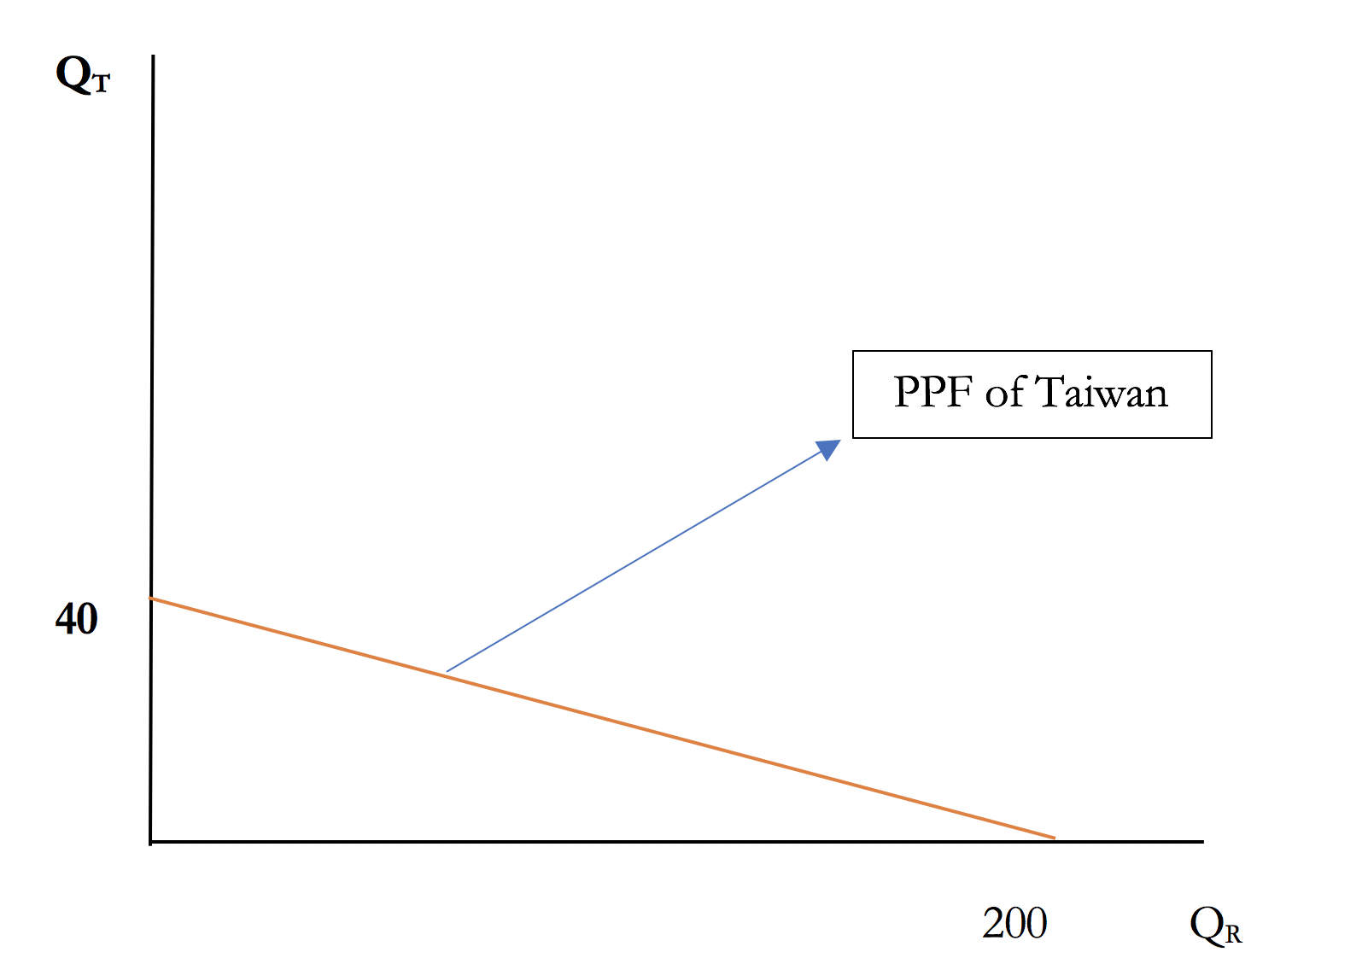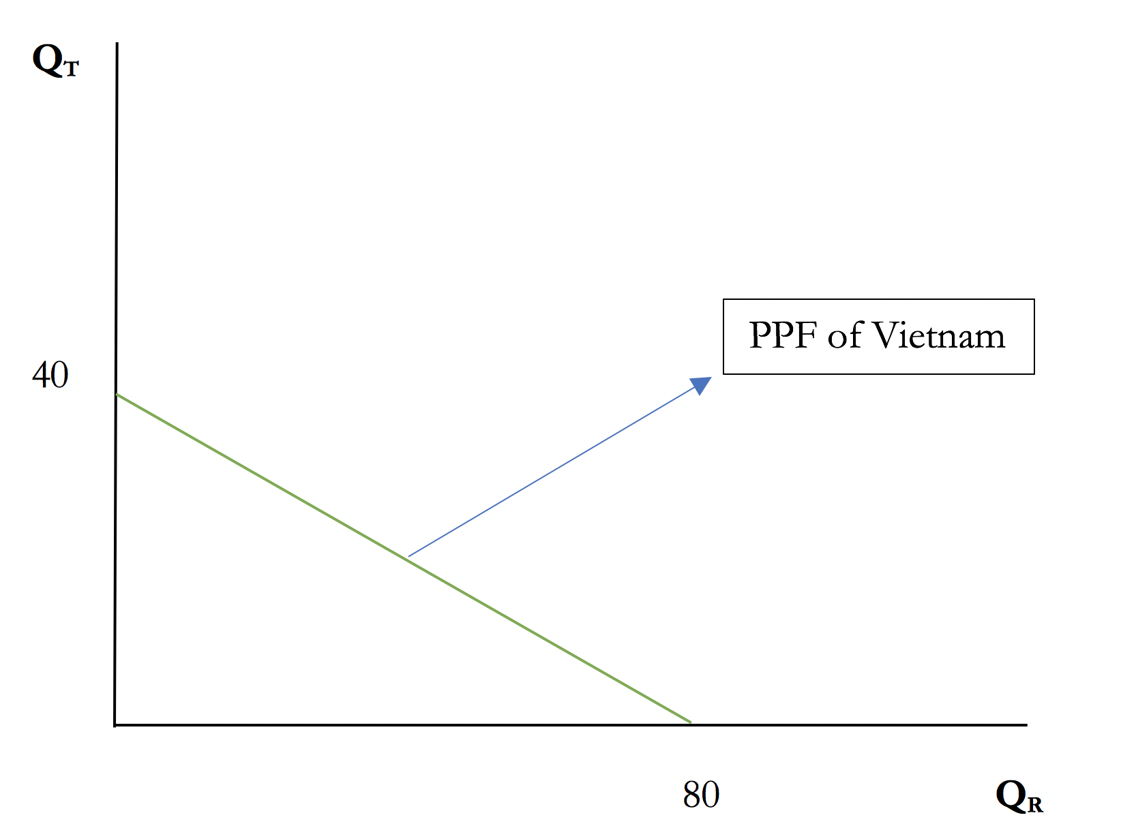

1. Determine the pre-trade relative price of telephones in Taiwan and Vietnam.

**Solution:**

The pre-trade relative prices of telephones in Taiwan and Vietnam are 5 and 2 respectively. (Since opportunity cost = relative price)

1. If the two countries engage in international trade, what will Taiwan produce and how many? Show the production point of Taiwan on its PPF.

**Solution:**

Because Taiwan has a comparative advantage in the production of radios, Taiwan will specialize in the production of radios. Taiwan will produce 50 *4 = 200 radios per hour.

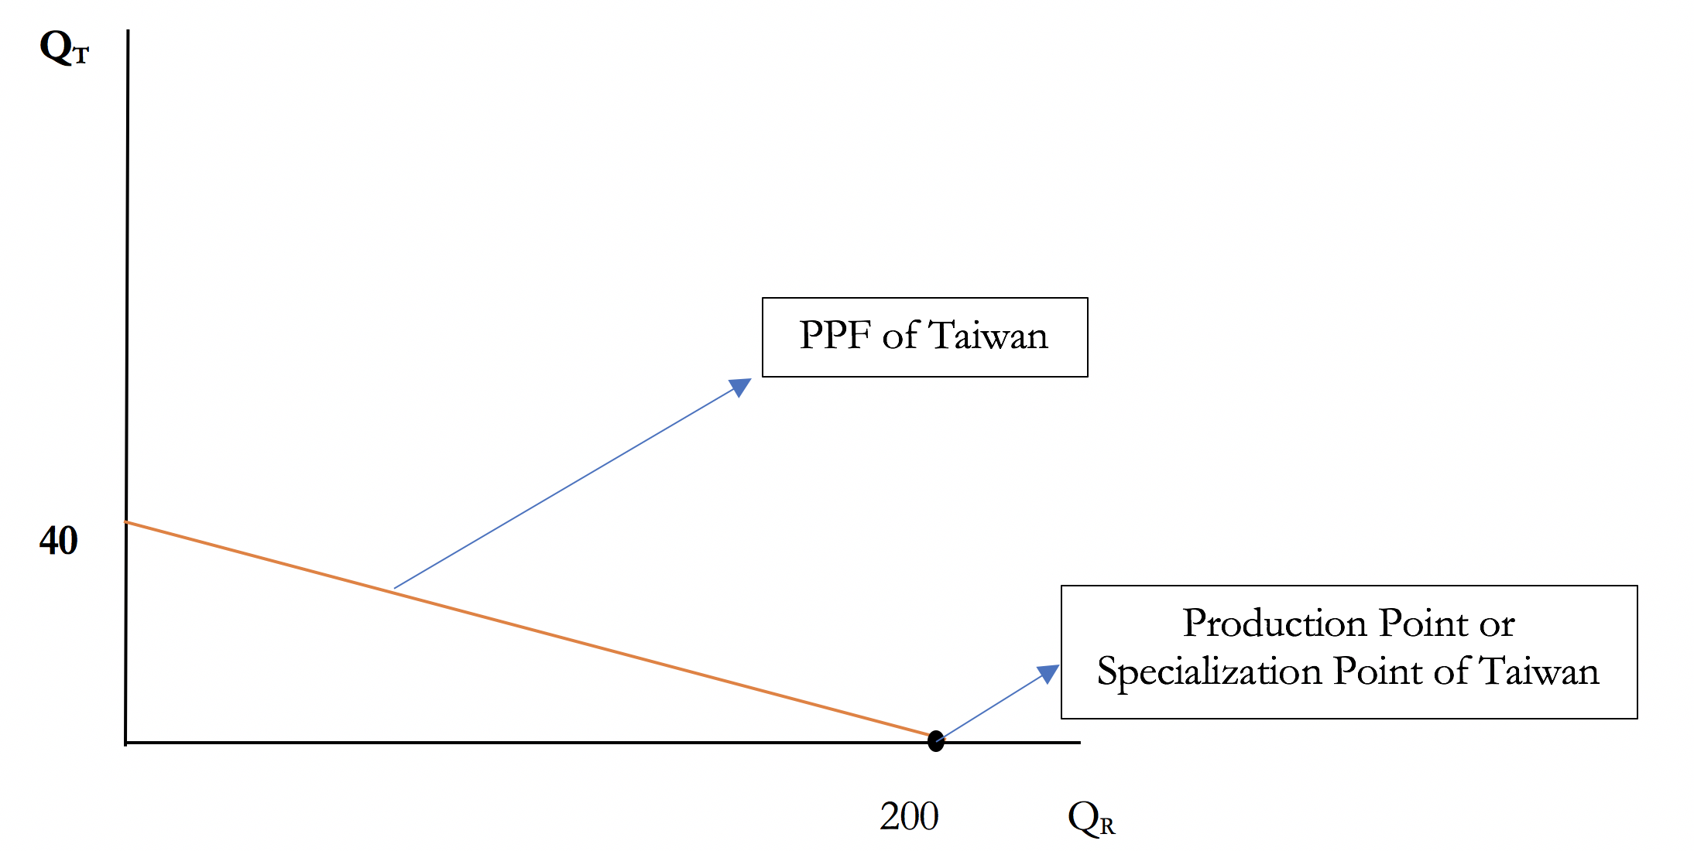

1. If the two countries engage in international trade, what will Vietnam produce and how many? Show the production point of Vietnam on its PPF.

**Solution:**

Because Vietnam has a comparative advantage in the production of telephones, Vietnam will specialize in the production of telephones. Vietnam will produce 5 *8 = 40 radios per hour.

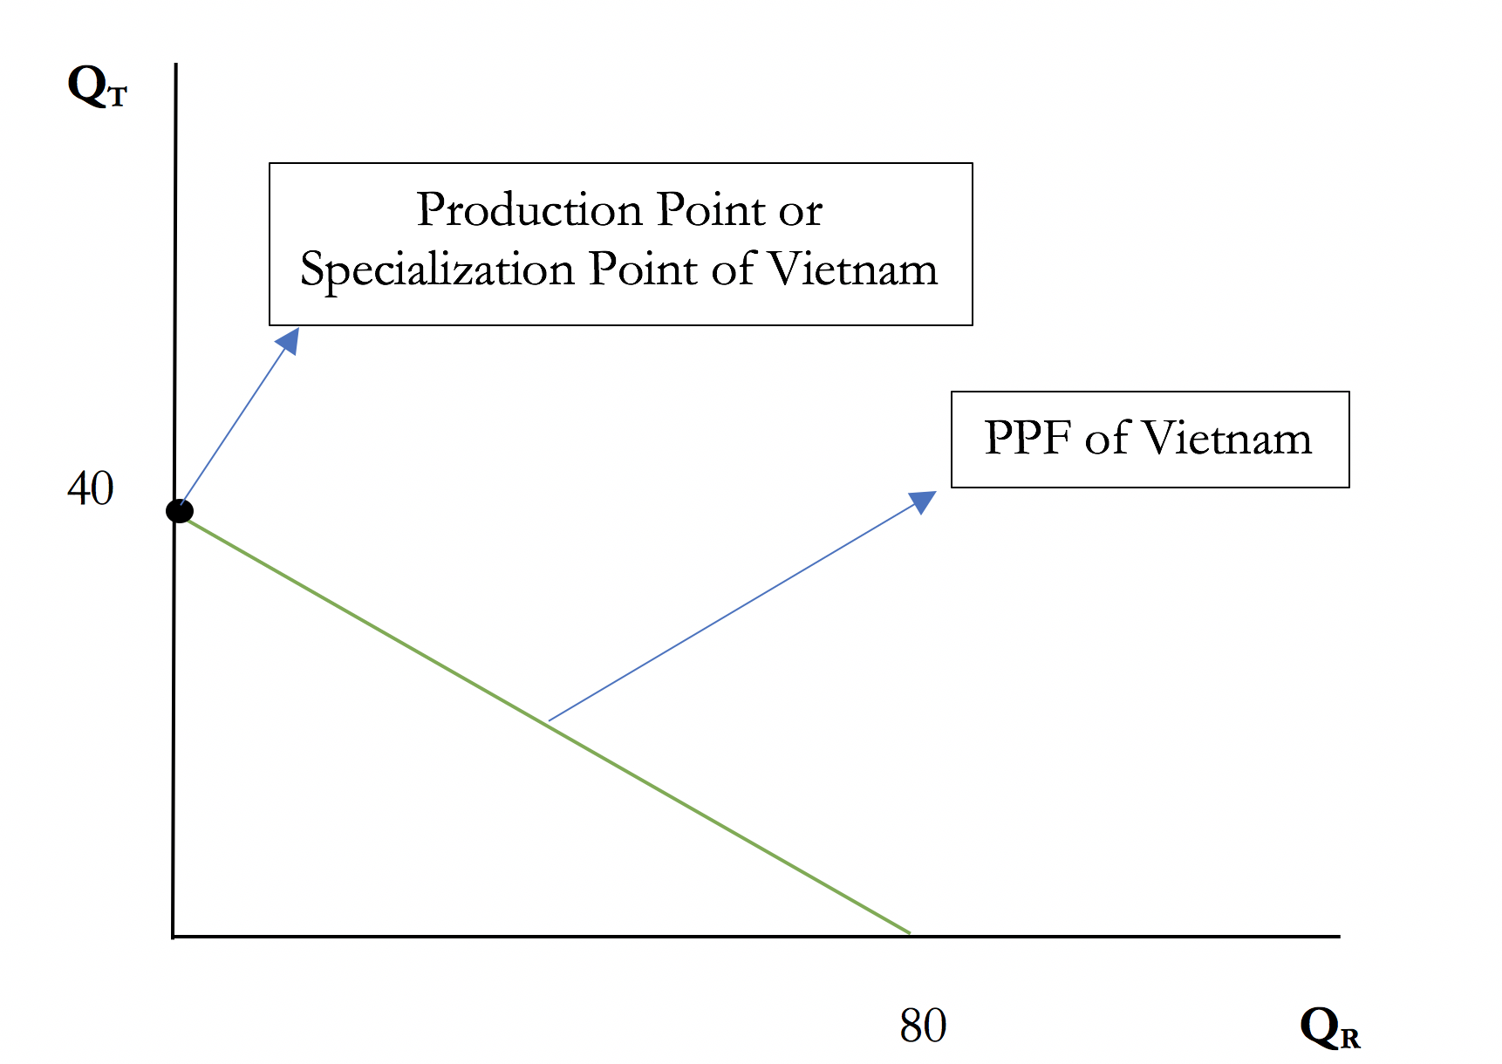

1. What is the real wage in Taiwan in terms of radio? What is the real wage in Vietnam in terms of telephone?

**Solution:**

Real wage in Taiwan in terms of radio = MPLRTaiwan = 50 units of radio

Real wage in Vietnam in terms of telephone = MPLTVietnam = 5 units of telephone

(Note: Real wage in Taiwan in terms of telephone = MPLRTaiwan * world relative price of Radio

= MPLRTaiwan * PR/PT in World Market

Real wage in Vietnam in terms of radio = MPLTVietnam * world relative price of telephone

= MPLTVietnam * PT/PR in World Market

In this problem, we don’t have information on relative prices in World Market, so we can’t solve for the respective real wages.

Suppose, PT/PR in World Market = 3, then:

Real wage in Vietnam in terms of radio = 5 * 3 units of radio

Real wage in Taiwan in terms of telephone = 50 * (1/3) units of telephones. )

1. Under free trade, what is the lower limit of the free-trade equilibrium price of telephone in terms of radio?

**Solution:**

PT/PR in Taiwan = 5

PT/PR in Vietnam= 2

The range of free trade equilibrium price of telephone in terms of radio is : 2 to 5.

So, the lower limit of this range is 2.

* **Empirical Questions:**

**Q5. Go to the website of FRED data. (30 Points)**

1. Go to this link: <https://fred.stlouisfed.org/series/BOPSTB>

Here you will find the Trade balance of the US for services. Print the graph, explain the trends, try to identify the period of trend shifts (showed by the gray color) and identify financial or economic events that happened during these periods which may have caused the change.

**Solution:**

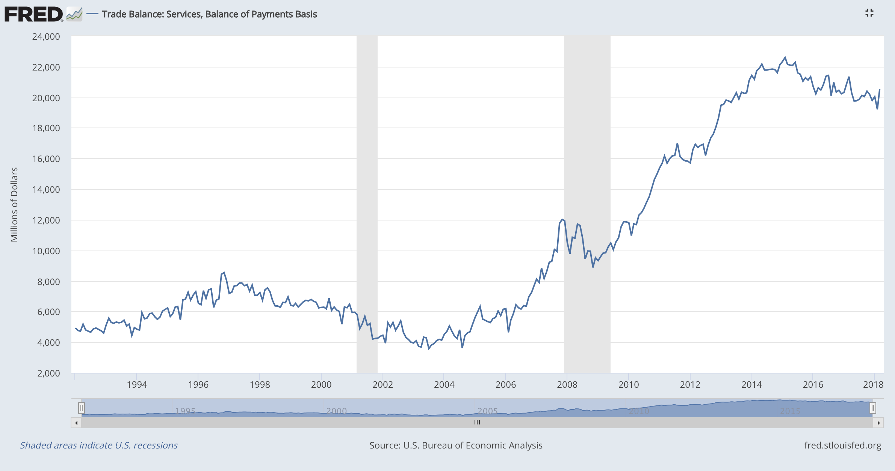

The graph of Trade balance of the US for services show an overall positive trend overtime, and the US has experienced trade surplus in services, that is, the service exports by the US exceeds the service imports by the US. There has been a negative trend starting from 1997 till 2003, this was majorly due to the U.S. stock market's "[Dot Com Bubble](http://en.wikipedia.org/wiki/Dot-com_bubble)" which began in [April 1997](http://politicalcalculations.blogspot.com/2008/03/recognizing-disorder-in-stock-market.html) and ended in [June 2003](http://politicalcalculations.blogspot.com/2007/12/sun-in-center.html). The 9/11 attack in 2001 also impacted trade. The trade surplus kept on increasing till the economy experienced another crisis in 2008. The sub-prime lending crisis (known as the “Global Financial Meltdown”) caused downward trend shift of trade balance for service. However, the trade surplus began to rise in late 2009 and it continued to grow till 2015.

1. Go to this link: <https://fred.stlouisfed.org/series/BOPGTB>

Here you will find the Trade balance of the US for goods. Print the graph, explain the trends, try to identify the period of trend shifts (showed by the gray color) and identify financial or economic events that happened during these periods which may have caused the change.

*(Hint: For some recent information check the Wall Street Journal article “U.S. Foreign-Trade Deficit Narrowed in March” by  Ben Leubsdorf. The article is posted on Blackboard.)*

**Solution:**

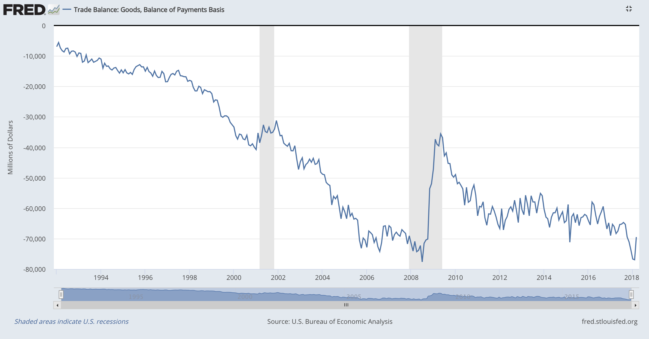

The graph of Trade balance of the US for goods show an overall negative trend overtime, and the US has experienced trade deficit in goods, that is, the goods imported by the US exceeds the goods exported by the US. There has been a negative trend in trade balance for goods (that is, trade deficit has increased, meaning trade balance has fallen) starting from 1997 till 2003, this was due to the U.S. stock market's "[Dot Com Bubble](http://en.wikipedia.org/wiki/Dot-com_bubble)" which began in [April 1997](http://politicalcalculations.blogspot.com/2008/03/recognizing-disorder-in-stock-market.html) and ended in [June 2003](http://politicalcalculations.blogspot.com/2007/12/sun-in-center.html). The 9/11 attack in 2001 also impacted trade. The trade deficit kept on increasing and reached a record low when the economy hit another crisis in 2008. The sub-prime lending crisis (known as the “Global Financial Meltdown”) caused downward trend shift of trade balance for goods, but this was recovered due to government intervention. The trend remained steady in the post crisis period. However, in 2018, the U.S. trade deficit level declined as hurricanes Harvey, Irma and Maria had disrupted port traffic and damaged parts of the Gulf Coast and Caribbean. The timing of Lunar New Year around February also caused import volatility. Although US exports increased in 2017 (6.8% in the first quarter), imports climbed (9.1% over the same period ) more and widened the trade gap.

1. Compare the two graphs that you obtained in part (a) and (b).

(*Hints: 1. Keep the cursor on the graphs and check the sign and magnitude of the values; 2. Direction of overall trend*)

**Solution:**

Comparing the two graphs, we can clearly see that trade surplus in services has been rising overtime, also the trade deficit in goods has been widened overtime. In terms of magnitude, the amount of trade deficit in goods is much larger than the amount of trade surplus in services.

* **Bonus Problem: (10 Points)**

**Q6.** Explain the concept of value added in the light of the Atlantic article “Which Countries Make Money Off the iPad?” by Jordan Weissmann. (The article is posted on Blackboard).

An ideal answer will explain what “value added” means and discuss the value chain of iPad following the article.

A sample answer written by a student:

“According to the article “Which Countries Make Money Off the iPad?”, the concept of “value added” means “making something worth more than the sum of its parts (or labor)”. For China, their main task is assembling the small device. This task does not add much value to the entire process which is why China only receives a value capture of about $8 out of the retail price of $499. This value capture essentially represents the profit after labor is subtracted. The designing and marketing of the iPad is what adds the most value. For this reason, the US value capture is equal to about $162 of the $499, or 32.5%

Since electronic goods manufactured by foreign countries yields little value for countries like China who are manufacturing the goods, some believe that bilateral trade statistics are misleading. The article also states that countries like China that start off specializing in manufacturing try to move up to complex parts and designing, in order to move up in the value chain.”

**OR**

Following the Wall Street Journal article “China’s Faux Comparative Advantage” by Peter Navarro, discuss the limitations of Ricardo’s comparative advantage theory. (The article is posted on Blackboard)

An ideal answer for this problem will make a connection between what has been learnt theoretically about the Ricardo Model in class and what Peter Navarro pointed out.

A sample answer written by a student:

“ From the textbook, we know according to Ricardo’s comparative advantage theory, countries trade goods with each other because of differences in terms of the technology used.

According to Peter Navarro, the textbook model is failing because China’s faux comparative advantage is the result of its state-directed investments, nonmarket economy, and disregard for the rule of law. The problem’s taproot is Chinese intellectual-property theft and the forced transfer of foreign technology as a condition of accessing China’s market. Most broadly, China’s “going out” strategy involves leveraging sovereign-wealth funds to capture the industries of the future.”

Another student points out:

“According to the Ricardian model, the US has comparative advantage in manufacturing because of better technology, large capital investment, and higher productivity of labor. But China still dominates traditional manufacturing as a result US has a bilateral trade deficit with China in goods.”

I encourage you to watch this video: <https://www.youtube.com/watch?v=KdY05PTu1dc>

which follows up Peter Navarro’s article.